**Exercise 1 – Written Exercises**

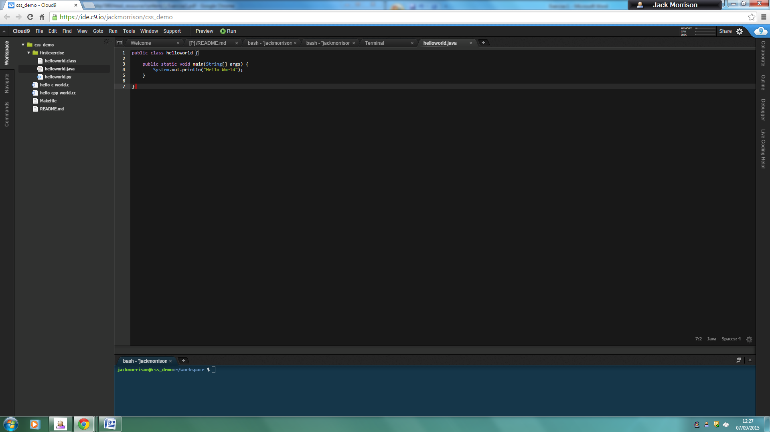

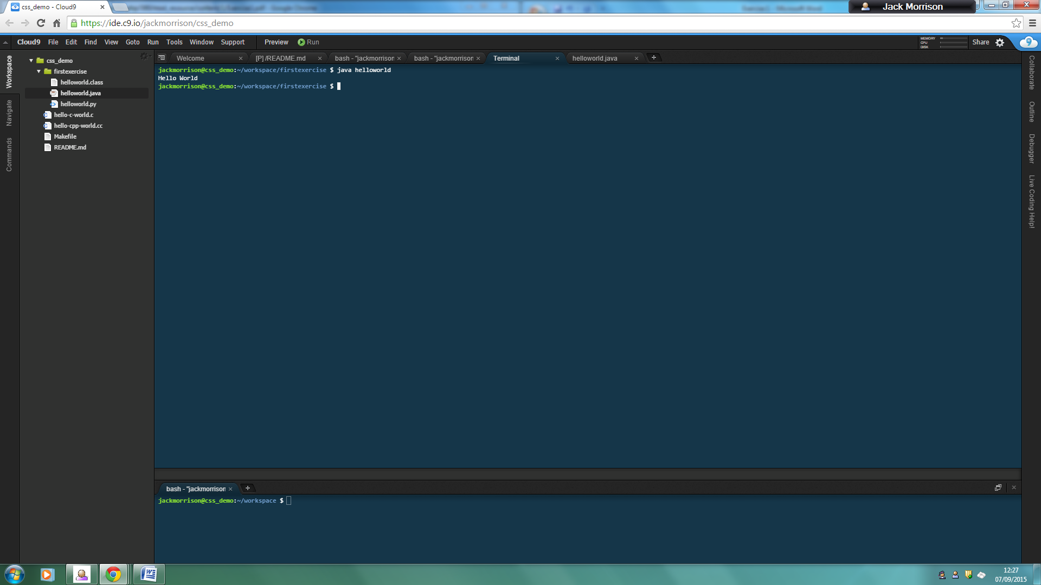

1. 1. twentyfour7- Valid
   2. 24seven – Not Valid
   3. class – Not Valid
   4. Class – Valid
2. 1. An int variable with an initial value of 22

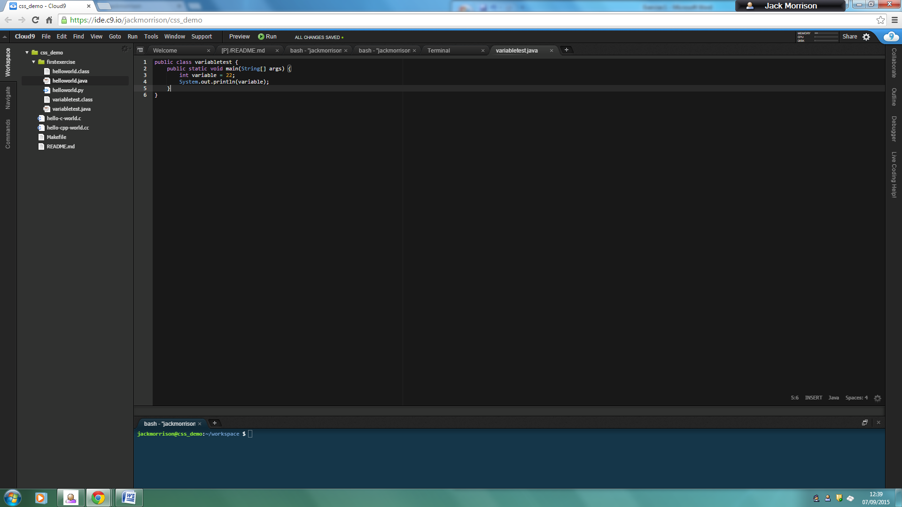

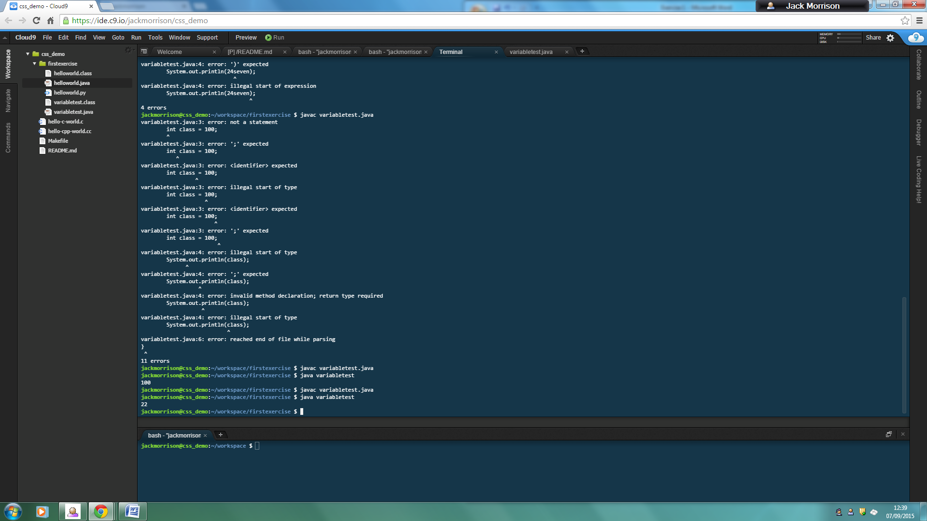

* 1. A double variable with an initial value of 3.25

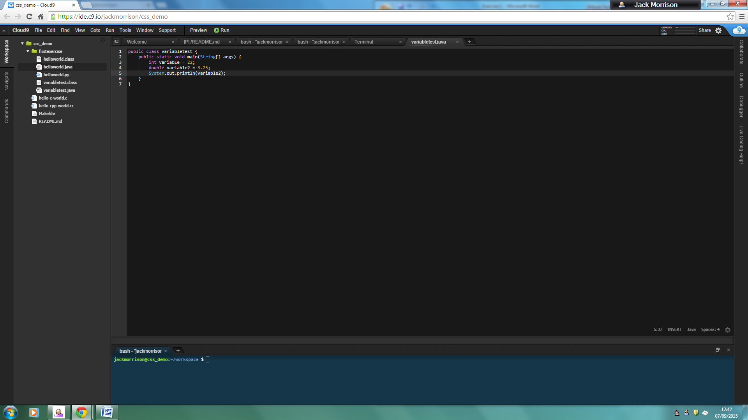

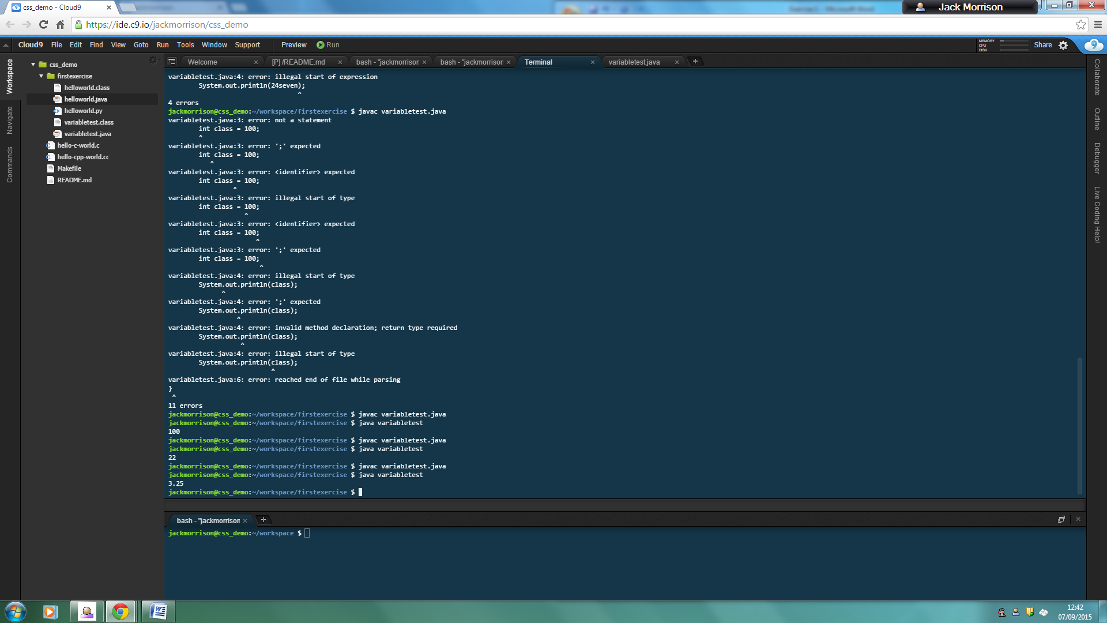

* 1. A double variable with no initial value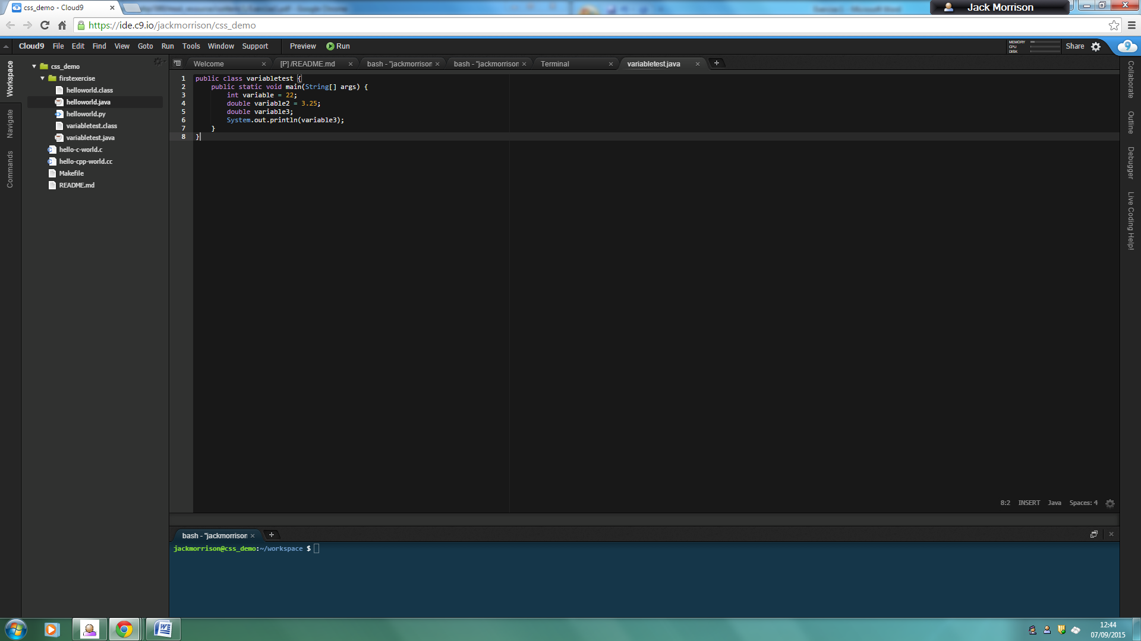
  2. A String with an initial value of "Welcome to Java".

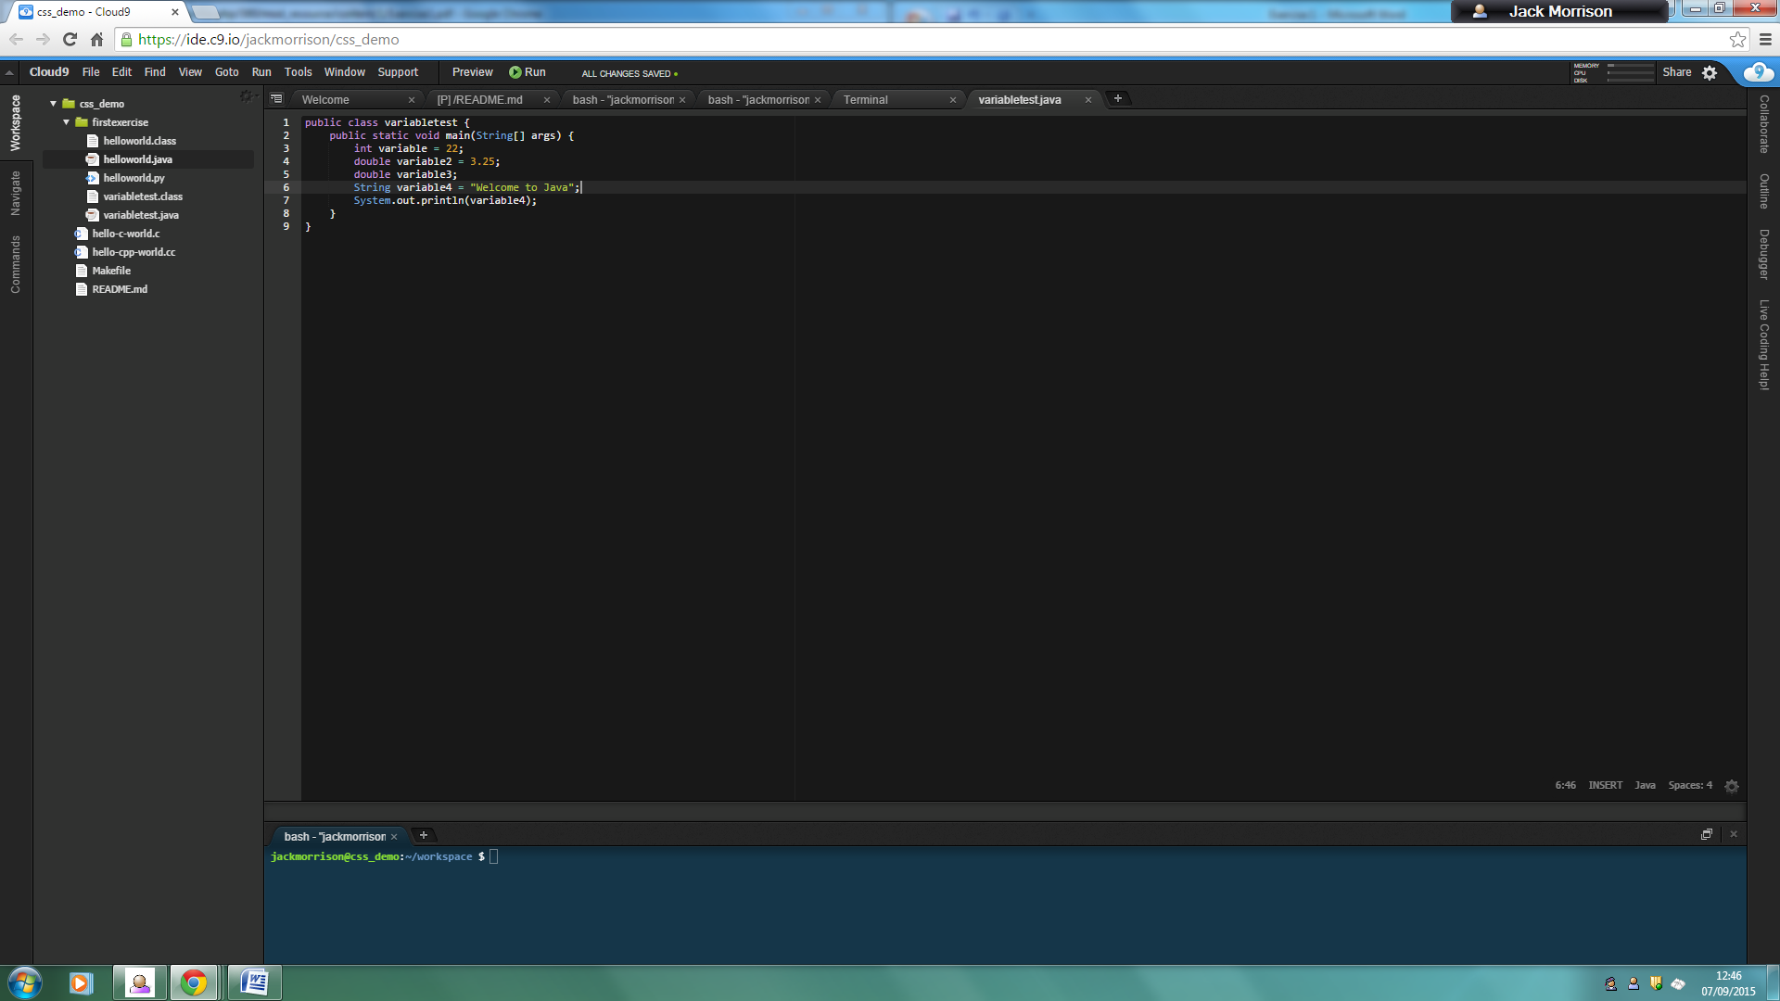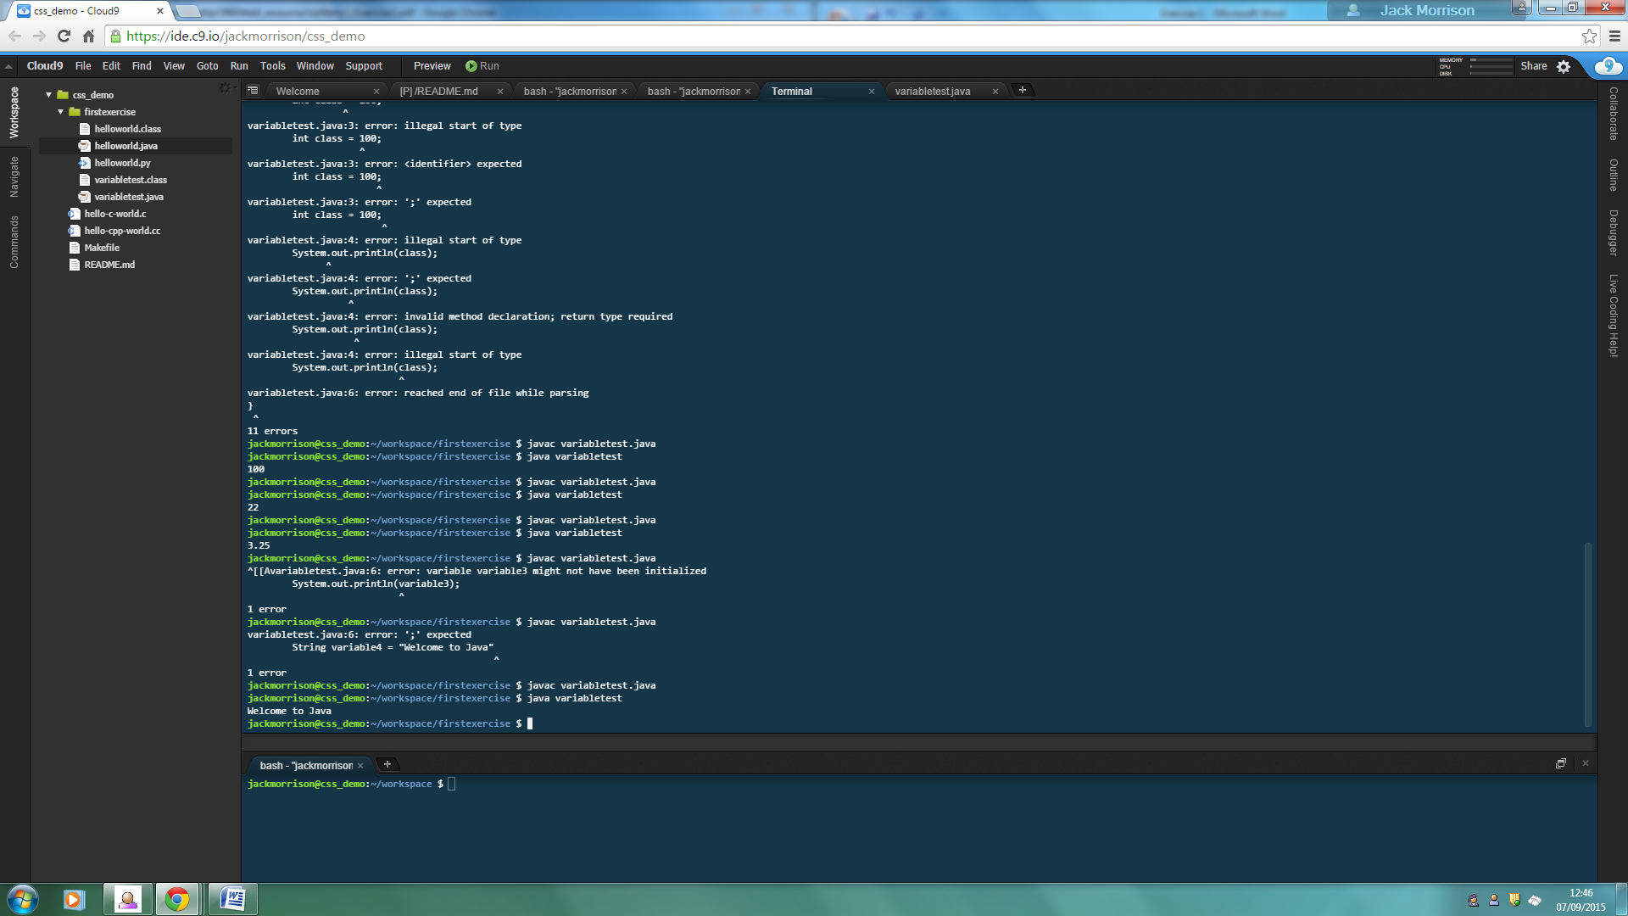

1. 1. (2*5)+3 = 13
   2. 2*(5+3) = 16
   3. 2*5+3 = 13
   4. 2+5*3 = 17
   5. 16-4/2 = 14
   6. 16/4-2 = 2

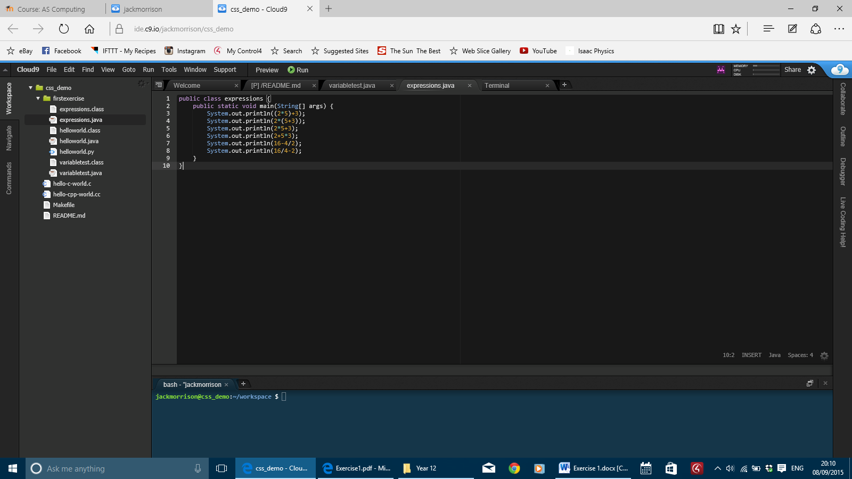

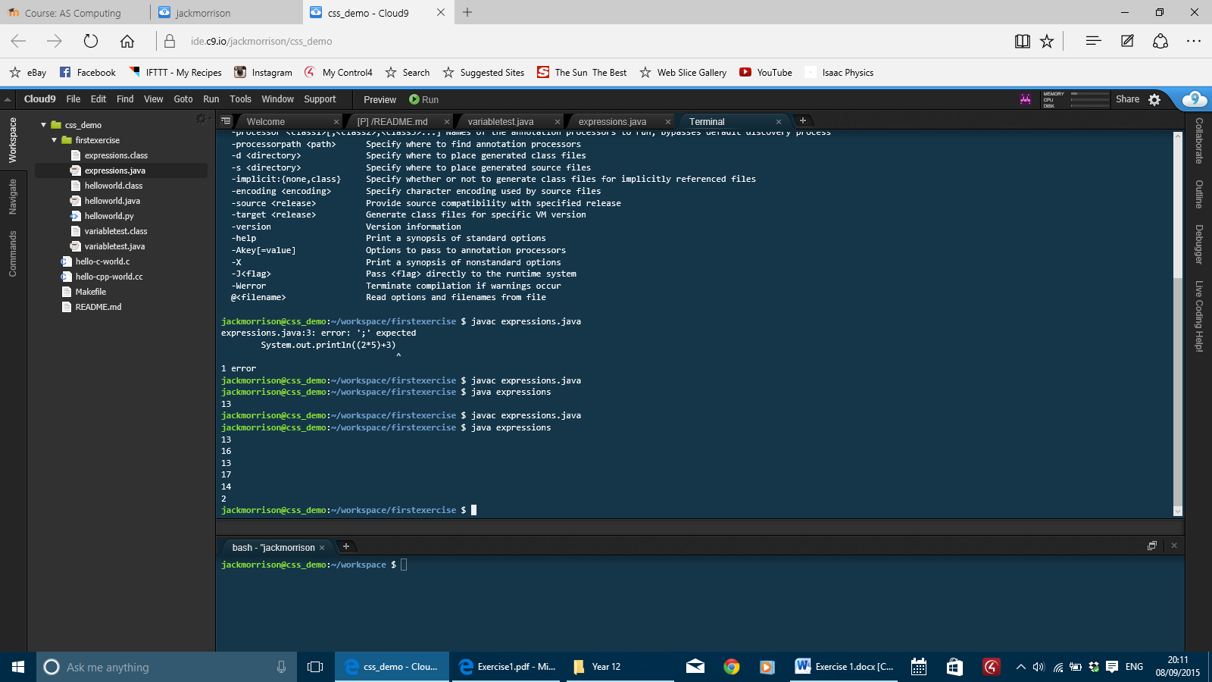

1. 1. 5/2 = 2
   2. 5/10 = 0
   3. 2*(5/2) = 4
   4. (3*5)/2 = 7
   5. 5/2*3 = 6
   6. 2+4*3/2-1 = 7
   7. 60/30/2 = 1

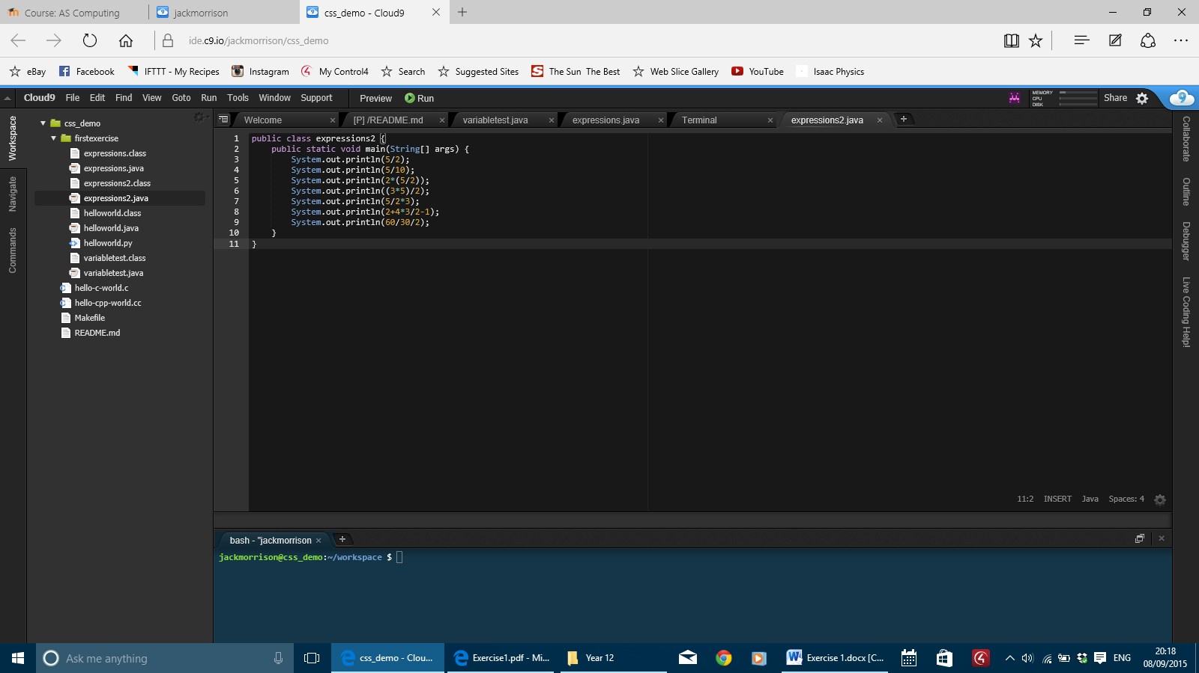

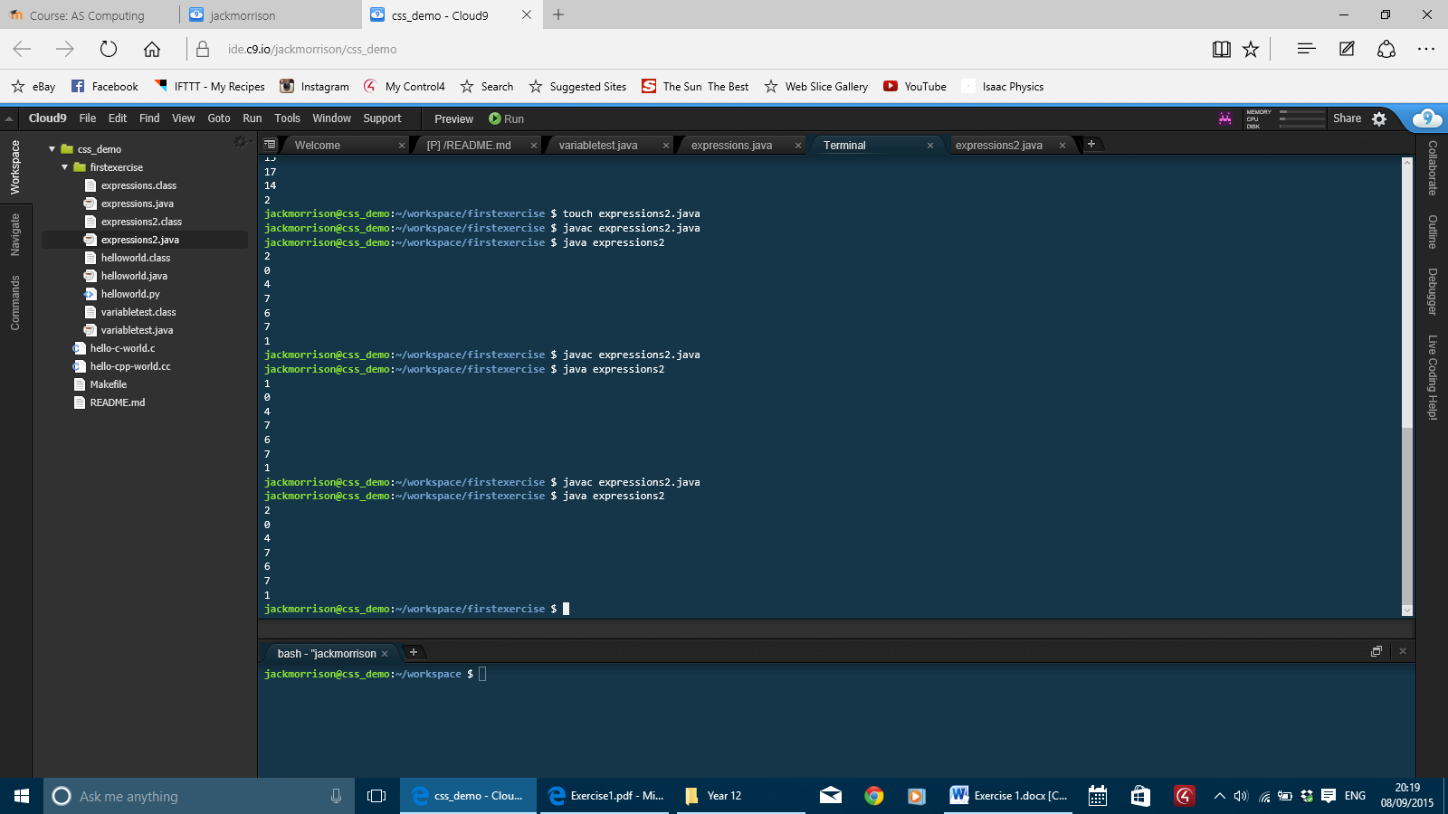

1. int a = 5;

int b = 30;

* 1. b/a = 6
  2. a+b/a = 11
  3. (a+b)/a = 7
  4. a*a+b/a = 31
  5. a*a/a+b = 35

